SESSION 10: SOLUTION DESIGN & VALIDATION
Exercises:
Scenario Writing Exercise
Scenario: "Sales rep needs to qualify a lead quickly before a meeting"
Student Task: Write 3 steps of the MAIN scenario and 1 ALTERNATE scenario.

Main Scenario:
- Lead’s detailed information and a quick background verification
- Trying to understand Lead’s interest (Products)
- Proof of conversation such as emails/ chat history
Alternate Scenario:
1a) In case of existing customer and poor payment history- show disqualified lead
---------------------------------------------------------------------------------------------------------------------

Exercise: Design a Lead Capture Form
Requirements:
- Capture: Name, Email, Company, Phone, Source
- Validate email format
- Show success/error messages

Task: Sketch wireframe on paper, then create in tool.

Paper:
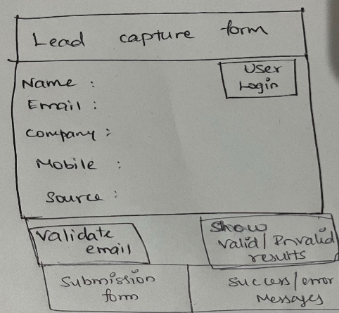

Tool Figma:

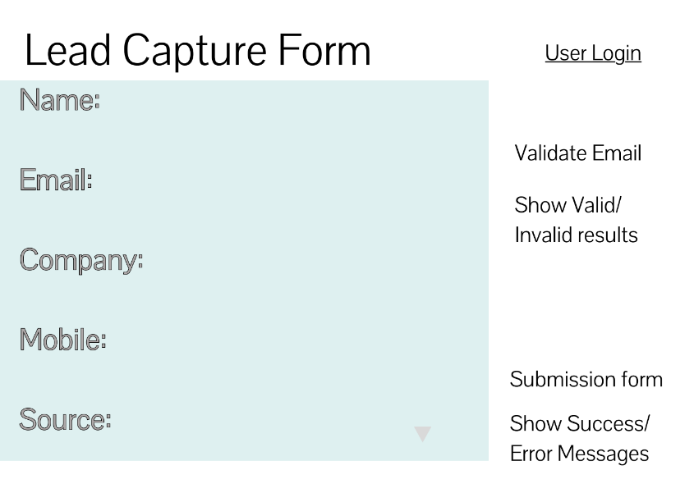

CRM dashBoard assessment Example or Exercise: ???????

PRACTICE:
Assignment: Design a "Customer Support Ticket Dashboard"

Hints: Requirements from Support Team:
1. See open tickets by priority
2. Assign tickets to agents
3. Track resolution time
4. Generate daily reports
Tasks:
1. Write 2 use cases (main + alternate scenarios)
2. Create wireframe (paper + tool)
3. Define acceptance criteria

Use cases:
Main Scenario:
- User/Agent logged into the CRM Support system
- Able to see all the tickets grouped by low, medium and high priorities
- Able to see the availability of agents present for the day
- Able to assign the tickets to the agents
Alternate Scenario:
2.a) High Prioirty tickets needs to solved on the same day.
2.b) Alert messages should be displayed – if its not resolved on same day.
4.a) Pop -ups should be displayed if the agent has already assigned with high priority tickets

Paper Wireframe:

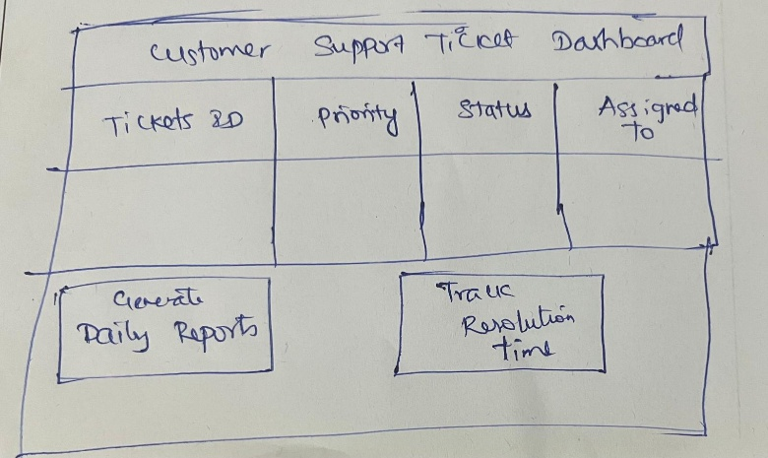

Tool Wireframe:

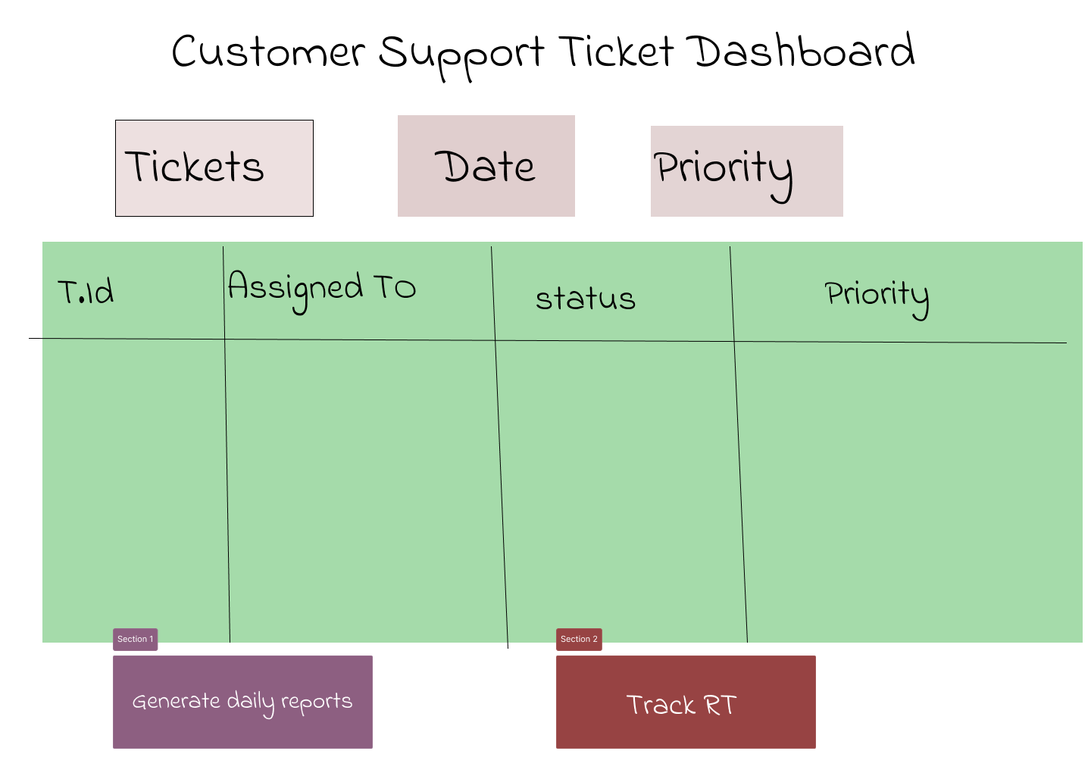

Acceptance Criteria:
- While assigning tickets, list of agents should be displayed
- After assigning, agent name should be updated and display successful message
- Resolution time should be faster for high priority tickets
- Alert messages should be displayed if high priority tickets are not resolved within the same day.

